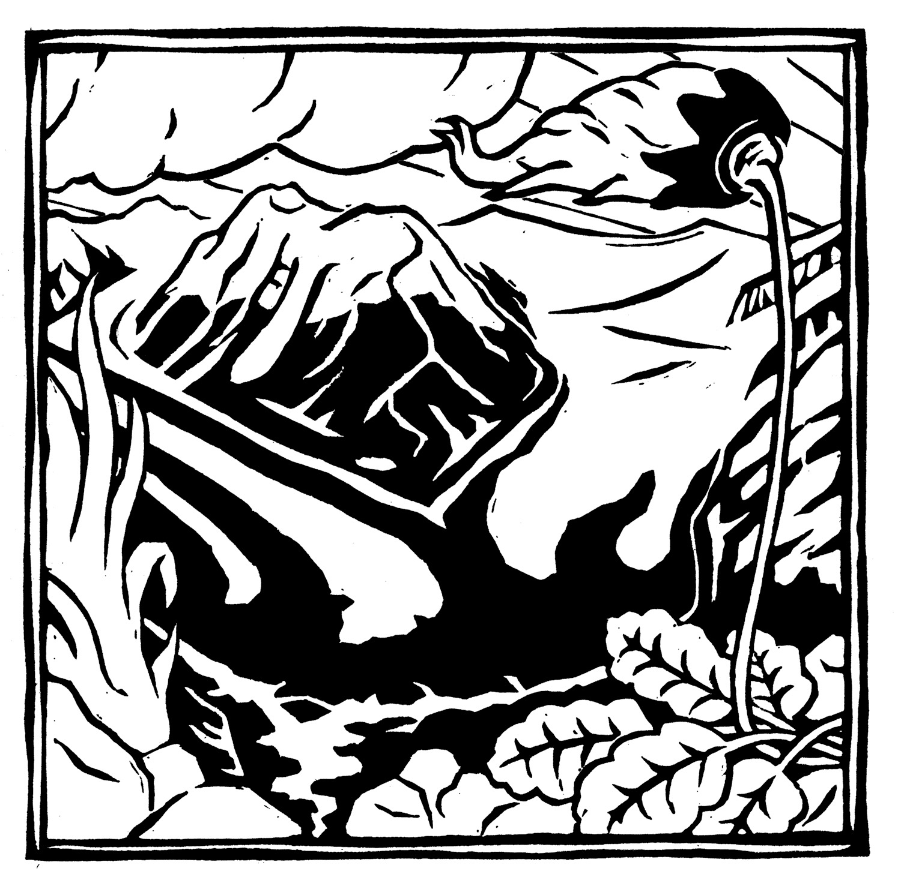
2017 Wrangell Mountains Center
Student Scholarship Program

The Wrangell Mountains Center (WMC) invites you to apply to receive a Scholarship Award for
Alaska Wrangell Mountains Field Studies

The Ed and Marion Doherty Scholarship Fund for Alaska Wrangell Mountains Field Studies is designed to assist meritorious students with financial needs. This scholarship is a “needs-based” award. A portion of our scholarship funds have been provided by a special bequest in honor of Ed LaChapelle, a long-time supporter and neighbor of WMC. He was a world-class snow scientist and avalanche expert who passed away February 1, 2007.

Contact the Scholarship Committee at 907-248-1016 or lilav@chugach.net if you have questions or need an application. Applications may also be downloaded from www.wrangells.org/fieldstudies-apply

SCHOLARSHIP APPLICATIONS MUST BE RECEIVED BY
Midnight Alaska Time on April 6, 2017

How to Apply for a Scholarship

- First you must apply to WMC/ESU Alaska Wrangell Mountains Field Studies for admission into the field studies (www.wrangells.org/fieldstudies-apply). Check the “Scholarship-dependent” box on the top right of your AWMFS application before submitting the application for review.
- After acceptance in the field studies, applicants must complete the entire Scholarship Application below, including the certification and a written response to the ending questions. Students must also submit two letters of recommendation (directions below).
3. Submit Scholarship Application to Wrangell Mountains Center, Attn. Scholarship Committee, PO Box 142972, Anchorage, AK 99514-2972 or email to Scholarship Committee at lilav@chugach.net. Mailed Scholarship Applications must be received no later than midnight Alaska Time April 6, 2017.

4. Preference points will be given to residents in or adjacent to the Copper Basin, or to Alaska State Residents.

Letters of Recommendation

We require one letter of recommendation from an employer, supervisor, or colleague and one letter from a post-secondary instructor. Please provide recommenders a copy of the recommendation form (found on Page 3).

Important Notes

The Scholarship Evaluation Panel will select scholarship recipients based on the merits of the application in relation to the goals and guidelines of the scholarship fund. Finalists may be interviewed prior to final selection. All information submitted will be kept confidential. For awardees, the scholarship will be deducted from the full student cost. At its discretion, the Evaluation Panel may forgo awarding scholarships for a year. Partial and full-ride scholarships are available.
Wrangell Mountains Center
SCHOLARSHIP APPLICATION

Name:

Date of Birth:

Mailing Address:

Telephone Number:

Email Address:

Parent/Guardian Name (if under 21):

Parent/Guardian Address and Telephone Number:

Present School Attendance (if applicable)

College Presently Enrolled In:

OR if you teach, school where you are employed:

School/College Address:

Attach a statement responding to the following questions, not to exceed two pages double-spaced:
- Introduce yourself. What about yourself, including your personal and academic history, is useful for us to know?
- How will a tuition scholarship assist you in attending Alaska Wrangell Mountains Field Studies? Please address your financial situation.
- How will attending the field studies fulfill your personal, educational, and professional goals?
- Why have you selected this particular field studies and why is enrolling in a term at WMC important to you in
terms of place and setting?

CERTIFICATION

I certify that all answers to the preceding questions, including the information in the written statement, are true and correct. I understand that false answers or deliberate omissions may be grounds for rejection of the application and withdrawal of any scholarship awarded.

Applicant’s Signature Date

Questions about Alaska Wrangell Mountains Field Studies Program or other programs offered?
Contact Wrangell Mountains Center Executive Director, Nate Anderson: nate@wrangells.org
Wrangell Mountains Center
RECOMMENDATION FORM

The student/participant who has given you this form is applying for a scholarship from the Wrangell Mountains Center, an educational institute connecting people with wildlands through art, science, and education in the Wrangell Mountains of Alaska.

You may use the questions below to help you write about the applicant. Please be sure to provide us with the information requested in bold type either on this form or in your attached letter.

Please give the completed recommendation form/letter back to the applicant, so they can submit the full Scholarship Application in time to be received by WMC no later than midnight Alaska Time on April 6, 2017.

Name of applicant:
In what capacity do you know the applicant?

How long have you known the applicant?
Reference name and position:
Reference signature: Date:

Please respond to the following questions, attaching additional sheets as necessary:
- Please address the applicant’s potential to gain personal, educational, or professional growth from attending this field studies.
- Why do you think this student is a good choice for this scholarship? Describe their focus in the arts, sciences, or education, or their interests in natural or cultural resource stewardship.

